MEASURE J TRAFFIC CONGESTION RELIEF AGENCY
TECHNICAL ADVISORY COMMITTEE

Meeting Agenda

Wednesday, January 6, 2021

11:00 AM
DUE TO COVID-19, THIS MEETING WILL BE CONDUCTED AS A VIDEO/TELECONFERENCE PURSUANT TO THE PROVISIONS OF THE GOVERNOR’S EXECUTIVE ORDERS N-25-20 AND N-29-20, WHICH SUSPEND CERTAIN REQUIREMENTS OF THE RALPH M. BROWN ACT. MEMBERS OF THE PUBLIC MAY NOT ATTEND THIS MEETING IN PERSON.

Committee members, staff and the public may participate remotely via Zoom at https://us02web.zoom.us/j/2641785183
or by calling 1 669 900 6833 using
Meeting 264 178 5183.

Public Comment
Public comment may be submitted in advance of the meeting via email to admin@ridetraffix.com. Please indicate in your email the agenda item to which your comment applies. Comments submitted before the meeting will be provided to the Technical Advisory Committee before or during the meeting. Please submit public comments as soon as possible so that they can be provided to the Technical Advisory Committee before, and, as feasible, during the meeting.

Any document provided to a majority of the members of the Measure J Traffic Congestion Relief Agency (TRAFFIX) Technical Advisory Committee regarding any item on this agenda will be made available for public inspection at the meeting. Members of the public may arrange to view documents after the meeting by calling the TRAFFIX Administrative Coordinator at 925-973-2649 during normal business hours.

- Call to Order
- Roll Call
- Public Comment
- Order of the Agenda
- Consent Calendar
  - Approve Summary of Actions from December 2, 2020 TAC Special Meeting
  - Approve TRAFFIX Monthly P&L Statements from October 2020 and November 2020
- Reports and Presentations
A. Receive TRAFFIX Administrative Coordinator Report
B. Receive First Student Location Manager Report
- Old Business
  - Receive Verbal Update on 2020-21 SRVUSD Distance Learning
- New Business
  - Review and Discuss TRAFFIX Addendum 3 with First Student
  - Review and Approve 2020-2021 TRAFFIX 6-Month Budget
- Approve TRAFFIX Board of Directors Meeting Agenda for January 19, 2021
- Adjournment: The next scheduled meeting is at 11:00 AM on March 3, 2021

I, Candace Andersen, Member of the Contra Costa County Board of Supervisors, hereby certify that the foregoing agenda was posted for the noted meeting at the County Offices 72 hours in advance.

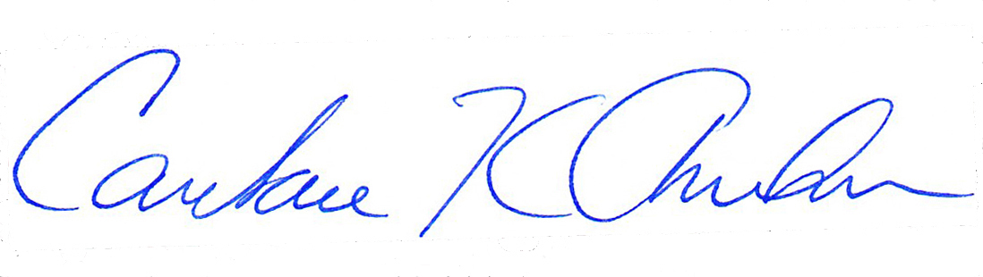
________________________________________________________________________
Candace Andersen, Board of Supervisors, Contra Costa County

In compliance with the Americans with Disabilities Act, the County of Contra Costa will provide special assistance for disabled citizens. If you need special assistance to participate in this meeting, please contact Robert Sarmiento at Robert.Sarmiento@dcd.cccounty.us. Notification 48 hours prior to the meeting will enable the County to make reasonable arrangements to ensure accessibility to this meeting. [28CFR 35.102-35.104 ADA Title II]

