DocuSign Envelope ID: 230EE032-134A-4A5B-B7C5-D97AE9D25346

MEASURE J TRAFFIC CONGESTION RELIEF AGENCY BOARD OF DIRECTORS

Monday April 10, 2023 4:00 PM - IN PERSON
San Ramon Valley School District Office 699 Old Orchard Drive, Danville, CA 94526

Written public comment may be submitted in advance of the meeting via email to admin@ridetraffix.com.
Please indicate in your email the agenda item to which your comment applies. Comments submitted before the meeting will be provided to the TRAFFIX Board of Directors before or during the meeting. Please submit public comments as soon as possible so that they can be provided to the TRAFFIX Board of Directors before, and, as feasible, during the meeting.

Any document provided to a majority of the members of the Measure J Traffic Congestion Relief Agency (TRAFFIX) Board of Directors regarding any item on this agenda will be made available for public inspection at the meeting. Members of the public may arrange to view documents after the meeting by calling the TRAFFIX Administrative Coordinator at 925-973-2649 during normal business hours.

- Call to Order – Chair Bratt called the meeting to order at 4:00pm.
- Roll Call – Kellie Fahey conducted roll call:
Chair Laura Bratt (SRVUSD), Director Rachel Hurd ( SRVUSD), Director Karen Stepper (Danville), Director Marisol Rubio (San Ramon), Gayle Israel (Representing Contra Costa County), Andy Dillard (Danville), Adam Cleary (Danville), Chris Weeks (San Ramon), Robert Sarmiento (Contra Costa County), Ilana Israel Samuels (SRVUSD), Michael Conneran (TRAFFIX attorney), Stella Kemp (SRVUSD), Kellie Fahey (TRAFFIX Admin Coordinator)
Absent: Director Hudson, Supervisor Andersen and Director Arnerich
- Public Comment - None
- Order of the Agenda – No Changes

- New Business
  - Review and Approve the reservation of bus passes for students eligible under SRVUSD’s Transportation Reimbursement Plan.
Ilana Israel Samuels and Stella Kemp reported that the school district and TAG developed a process for identifying and communicating plans for bus passes under the approved Transportation Reimbursement Program for TRAFFIX for the 23/24 school

year to be paid by the district for “unduplicated students" in the 23/24 school year.
TAG has recommended that the Board approve a plan to reserve 69 TRAFFIX bus passes for eligible families who have submitted the request form in advance of the opening of the spring 2023-2024 pass sales period.

Motion to approve by Director Gayle Israel, Second Director Karen Stepper
Motion passes 5-0

V1. Adjournment: The next scheduled meeting is Monday, May 22, 2023 at 3:30 PM at the San Ramon Valley School District office.
CERTIFICATION

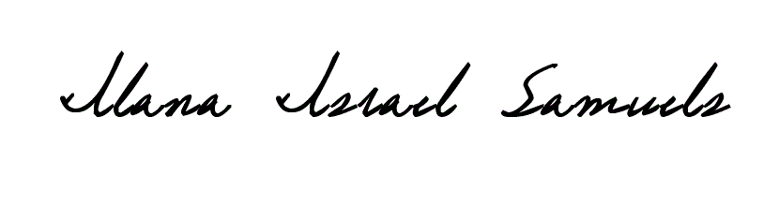
I hereby certify that the foregoing agenda was posted at the San Ramon Valley School District Office, 699 Old Orchard Drive, Danville, CA 24 hours in advance of the noted meeting.

Ilana Israel Samuels, SRVUSD Communications & Community Relations Community

